COB and Auction Enhancements

High Level Design

Prepared By:

Table of Contents
Table of Contents 1
Re-COA 2
New Trading Properties 2
New XML based properties 2
Broker Processor and Auction Processor related changes – BC changes 4
New ReCOAManagerHome 5
This home will manage the timer states for the reCOA. 6
Trading Property Related changes 9
XML Related changes 9

Re-COA
Please review the requirement doc for this feature before reading through this section.
Re-auction orders in certain circumstances from COB.

NOTE: Currently, once a complex order is booked in CBOEdirect, it rests until a user decides to hit it. Re-auctioning the resting order is expected to attract users that are monitoring COA auctions but not COB.

New Trading Properties
- The number of ticks away will be a new class level trading property.
  - CBOEdirect will re-COA resting COB orders when they N-ticks away from being marketable at CBOE.
  - Trading Property : TicksAwayForReCOA
- A class level timer will be added as a new trading property
  - Once a complex order is re-COA’d, it will not be re-COA’d again for X milliseconds (first timer).
  - Trading Property : ReCOAInterval
- Number of Re-COA attempts will be a new class level trading property.
  - The resting complex order will be re-COA’d Y times (# attempts).
  - Property Name: numberOfAttemptsForReCOA
- Sleep timer will be a new class level trading property.
  - After the resting complex orders has been re-COA’d Y times, it will not be re-COA’d again for Z seconds (sleep timer).
  - Property Name: sleepTimerForReCOA

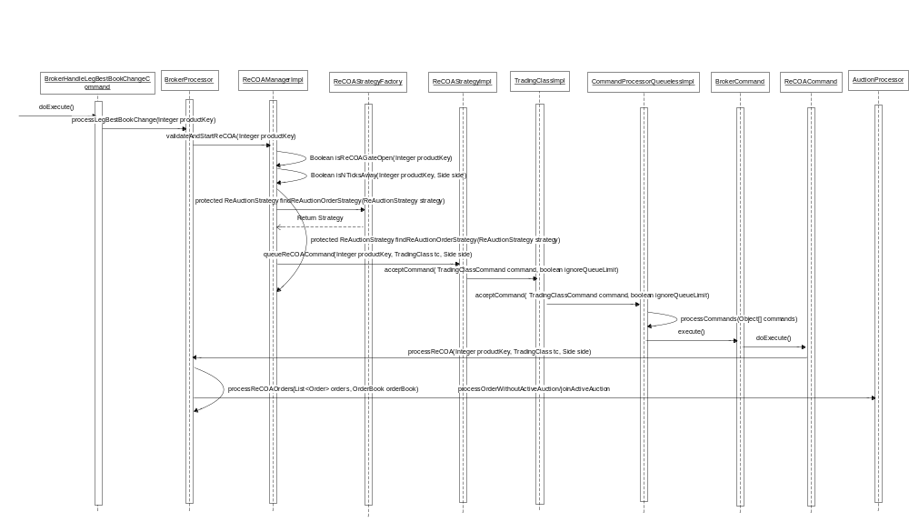

Broker Processor and Auction Processor related changes – BC changes
- ReCOAStrategyFactory.java
Location: server\Java\impls\com\cboe\businessServices\brokerService
Define a new class public class ReCOAStrategyFactory.This class will contain the following methods:
- Define method public static void initReCOAStrategy(String reCOAStrategy). This method is used to instantiate the instance of ReCOAStrategy.

- Define method protected ReAuctionStrategy findReAuctionOrderStrategy(String strategyImpl). This method gets strategy for reCOA order strategy.

- BrokerProcessor.java
Location: domain\Java\interfaces\com\cboe\interfaces\domain
Modify BrokerProcessor interface to add below method -
- Declare processReCOA(Integer productKey, TradingClass tradingClass, Side side) throws DataValidationException, SystemException method.

- BrokerProcessorSpreadHybridImpl.java
Location: server\Java\impls\com\cboe\businessServices\brokerService
- In the method processLegBestBookChange (Integer productKey), call the validateAndStartReCOA(Integer productKey) method of ReCOAManagerImpl class.

- Define processReCOA(Integer productKey, TradingClass tradingClass, Side side) throws DataValidationException, SystemException method .
  - This method will call processReCOAOrders(List<Order> orders, OrderBook orderBook).

- Define method processReCOAOrders(List<Order> orders, OrderBook orderBook) : This method calls either processOrderWithoutActiveAuction or joinActiveAuction method on AuctionProcessor depending on whether auction is alive or not.

- ReCOAStrategy.java
Location: server/Java/interfaces/com/cboe/interfaces/businessServices/brokerService
Define a new interface public interface ReCOAStrategy. This class will contain the following
methods:
- Declare public void queueReCOACommand(Integer productKey, TradingClass tc, Side side)

- ReCOAStrategyNullImpl.java
Location: server/Java/impls/com/cboe/businessServices/brokerService
- This class implements ReCOAStrategy interface.
- This method will provide null implementation for public void queueReCOACommand(Integer productKey, TradingClass tc, Side side).

- ReCOAStrategyImpl.java
Location: server/Java/impls/com/cboe/businessServices/brokerService
- This class implements ReCOAStrategy interface.
- Define method queueReCOACommand(Integer productKey, TradingClass tc, Side side) -
  - This method creates an object of ReCOACommand with broker, product key, Trading class object and side.
  - This then calls TradingClassImpl.acceptCommand() method and pass the object of ReCOACommand as the parameter. On execution of command, processReCOA method of ReCOACommand is called.

- ReCOACommand.java
Location: server\Java\impls\com\cboe\businessServices\brokerService
Define a new class public class ReCOACommand extends BrokerCommand implements Copyable .This class will contain the following methods:
- Define method protected void doExecute() throws java.lang.Exception . This method calls public void processReCOA(getProductKey(), getTradingClass(), getSide()) method of BrokerProcessorSpreadHybridImpl .

- OrderBookImpl.java
Location: server/Java/impls/com/cboe/businessServices/orderBookService/
- Modify acceptTradable(Tradable aTradable) method . Whenever best book is updated, this method resets the reCOA gate for that product by calling OrderBookEditor.resetReCOAGate method

- OrderBookEditor.java
Location: server/Java/impls/com/cboe/businessServices/orderBookService
- Declare a new abstract method public abstract void resetReCOAGate(Tradable aTradable).

      - OrderBookSpreadEditor.java
Location: server/Java/impls/com/cboe/businessServices/orderBookService
- Define method public void resetReCOAGate(Tradable aTradable).
    - This method will check whether the number of ReCOA attempts is greater than 0 and accordingly will reset the ReCOA gate indicator by calling the setReCOAGatesResetIndicator() method.

- AuctionProcessorSpreadHybridImpl.java
Location: server\Java\impls\com\cboe\businessServices\brokerService
- processReCOAOrders(List<Order> orders, OrderBook orderBook) method will call the auction processor methods as the flow diagram shown below.
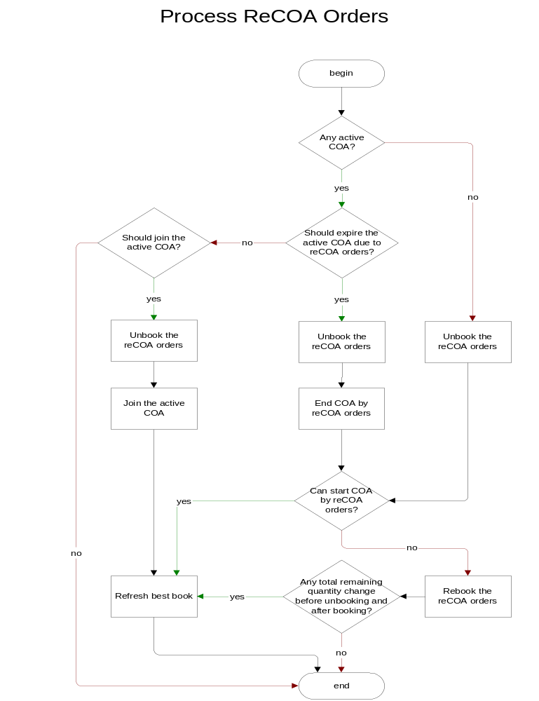

ReCOAManagerHome :
Location: server/Java/interfaces/com/cboe/interfaces/businessServices/brokerService

This interface defines create () and find () method to get instance of ReCOAManager Implemantation.
It also defines getClassKey() method to get the class key for the product key passed and findByClass() method to get the ReCOAManager object.

ReCOAManagerHomeImpl:
Location: server/Java/impls/com/cboe/businessServices/brokerService

- Implements ReCOAManagerHome.java and provides implementation for create () find () and getClassKey() method.
- Implement create() to provide an instance of ReCOAManagerImpl
- Implement find() to find an instance of ReCOAManagerImpl
- Implement getClassKey to get the Class Key for the product key passed.
- Implement findByClass to get the ReCOA Manager object for the class key passed.
- Implement goSlave() and goMaster() method.
- Define method resetReCOAGates() method for resetting it using ar command either by product key or class key.
- Define method displayReCOAGates() method for displaying the ReCOA properties for the product key passed using ar command.

ReCOAManager :
Location: server/Java/interfaces/com/cboe/interfaces/businessServices/brokerService

Define following methods in an interface-
  - validateAndStartReCOA(final Integer productKey)
  - resetGatesForReCOA - This method will reset all the timer when BestBookEvent is received.
  - reCOAStarted(final Integer productKey, final long currentTime) - This method will update the ReCOA interval and sleep timer whenever COA is started.

ReCOAManagerImpl :
Location: server\Java\impls\com\cboe\businessServices\brokerService

This class implements ReCOAManager interface.
- This home will manage the timer states for the reCOA.
- Listens for the BestBookEvents for spreads.
- Define product level hashmap for reCOA timers.
This hashMap is declared as private Map<Integer, PropertyList> productKeyMap. In this hashMap , productKey will be used as the key and PropertyList object as the value.

- Define an inner class as PropertyList. This class maintains the value for Number of ReCOA attempts, RecOA interval, SleepTimer and ticks away for a product.
This class declares the following variables as well as getters and setters for each of them:
- Number of Attempts
- ReCOA Interval
- Sleep Timer
It contains a method public void resetAllProperties(long currentTime) to reset all the above properties.
- Define a new method public ReCOAStrategy findReAuctionOrderStrategy(String strategyImpl). This will
- Read the <reCOAStrategyImpl> property value from BrokerProcessor.xml through get BrokerProcessorHome().getProperty(StrategyImpl). This value will then be passed as the parameter to the below method.
- Call ReCOAManagerImpl. findReAuctionOrderStrategy (String strategyImpl) method.
- Define a new method validateAndStartReCOA(Integer productKey) which further calls the following methods:
    - Boolean isReCOAGateOpen(Integer productKey) . If returns true then execute step 2.
    - Boolean isNTicksAway(Integer productKey, Side side)
    - If above both method returns true i.e top of book is auctionable then get the strategy by calling below method
protected ReAuctionStrategy findReAuctionOrderStrategy(ReAuctionStrategy
strategy)
    - Call queueReCOACommand(Integer productKey, TradingClass tc, Side side) on ReCOAStrategy class.

- Define method isReCOAGateOpen (Integer productKey) this method will return true/false depending upon the timer gates.
- If there are no values in the hash map corresponding to the productKey passed as the parameter in the class ReCOAManagerImpl, the default values of variables in the object of PropertyList will be set as
Number of attempts = 0
ReCOA interval = current time
Sleep Timer = 0
As this would be the First ReCOA attempt for given product, Method will exit with return value as ‘True’.
- Check auction properties for following conditions:
    - Whether sleep timer is 0 or over, if no return false and if yes goto next step.
    - Check whether first timer is over, if no return false and if yes goto next step.
    - Check whether no. of attempts has not exceeded, if no return true else return false.
- Define method calls Boolean isNTicksAway(Integer productKey, Side side) .In this, we will see whether top of book for the same side is N-ticks away from being marketable , if not we do the same check for the opposite side.
- Get the best book price from the order book.
orderBook.getBestPrice(side);
- Add N-ticks (as trading property) to above price.
TradingClass tc = orderBook.getTradingProduct().getTradingClass();
Price newPrice = tc.addTicks(price, n);
- Determine if a price is at or outside the derived quote
Boolean isNTicksAway = (DQ.isAtDQ(newPrice, SideFactory.getAsDefinedSide()) || DQ.isOutsideDQ(newPrice, SideFactory.getAsDefinedSide()))

- Define a method to get TradingClassHome. This will be used to get trading properties for defined class.
- Define method resetGateForReCOA()
      - This method will reset number of attempts and timer values when BestBookEvent is received.
- Define method reCOAStarted(Integer productKey)
      - This method will update the current timer when called. This method will be called from auction processor when reCOA is started. In this method, check the following:
- Whether number of attempts as stored in hashMap is less than that of XML value, if yes update the no. of attempts by incrementing it by 1 ReCOA Interval by the current time and if no goto the next step.

- If number of attempts in hashMap is equal to XML value, then it indicated that it is next cycle for ReCOA attempts. Update the no. of attempts by 1 and ReCOAInterval and sleepTimer by the current time.

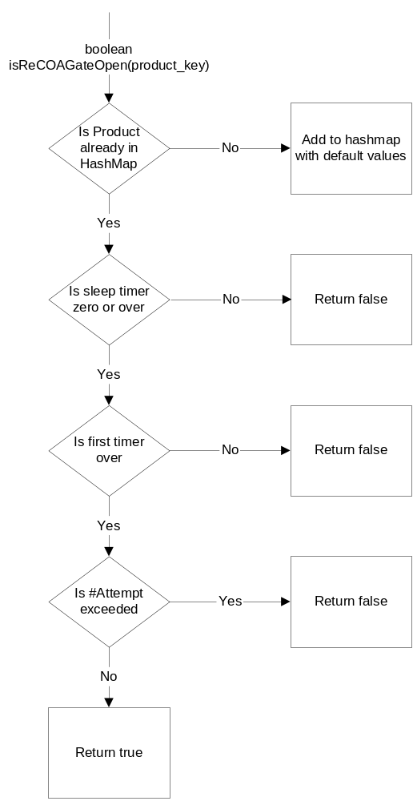

XML Related changes
- HybridTradeServer.xml
Location: server\properties\xml
Add ReCOAManagerHome to HybridTradeServer in BrokerContainer.

- HybridTradeServer1Files.txt
Location: server\properties\processes
Add ReCOAManagerHome to HybridTradeServer xml list.

- BrokerProcessor.xml
Location: server\properties\xml
Add a new tag as ‘reCOAStrategyImpl’. This tag holds name of the strategy class to be used as value.
<reCOAStrategyImpl>com.cboe.businessServices.brokerService.ReCOAStrategyImpl</reCOAStrategyImpl>

